附件2：中英文摘要模板（页面设置：上3厘米，下、左、右2.5厘米！单倍行距！）

Integrated Computational Materials Engineering (ICME) for developing the cemented carbides [Arial, 12]
Weibin Zhang¹, Yong Du¹, et al. [Arial, 10]
1 State Key Laboratory of powder metallurgy, Central South University, Changsha, Hunan, 410083 [Arial, 10]
E-mail:yong-du@csu.edu.cn [Arial, 10]
Abstract: The ICME (Integrated Computational Materials Engineering) for cemented carbides aims to combine key experiments with multi-scale numerical simulations from nano (10⁻¹⁰~10⁻⁸ m) to micro (10⁻⁶~10⁻⁴ m) to meso (10⁻⁴~10⁻² m) and to macro (10⁻²~10 m) during the whole R&D (research and development) process of cemented carbides. Using integrated analysis of the composition-processing-structure-properties, the methodology for developing cemented carbides is promoted from trial and error to scientific design, which will significantly speed up the R&D of cemented carbides and reduce the costs. In this paper, multi-scale simulation approaches including Ab-initio, CALPHAD (CALculation of PHAse Diagram), phase field, and finite element method together with experimental methods characterizing structure and properties are elaborated. The function of each method in the R&D of cemented carbides is carefully discussed. Based on ICME, the framework for R&D of cemented carbides, involving end-user demand, product design and industrial design, is established. Several application examples are presented to describe the important role of ICME during the development stage of cemented carbides, which provides an innovative pattern for R&D of advanced cemented carbides.
Keywords: cemented carbides; ICME; multi-scale numerical simulations [Arial, 10]

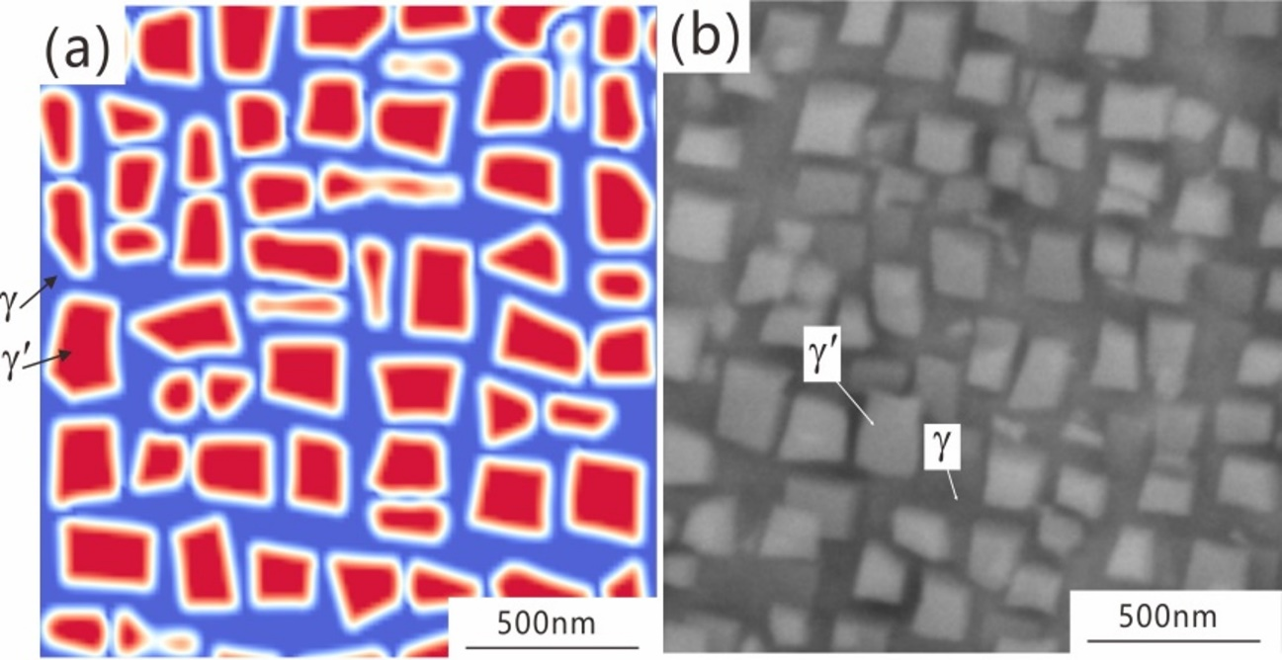
Fig. Microstructue of the Al-Co-Ni matrix phase after aging treatment: (a) phase filed modeling, (b) experimental result.

研发硬质合金的集成计算材料工程[宋体四号]
张伟彬¹,杜勇¹等[宋体,小四号]
¹中南大学粉末冶金国家重点实验室，湖南省长沙市，410083 [宋体小四号]
E-mail:yong-du@csu.edu.cn[宋体小四号]
摘要：用于研发硬质合金的集成计算材料工程是将微观（10⁻¹⁰~10⁻⁸ m）、细观（10⁻⁶~10⁻⁴ m）、介观（10⁻⁴~10⁻² m）和宏观（10⁻²~10 m）等多尺度计算模拟和关键实验集成到硬质合金设计开发的全过程中，通过成分–工艺–结构–性能的集成化分析，把硬质合金的研发由传统经验式提升到科学设计,从而大大加快硬质合金材料的研发速度，降低研发成本。详细阐述了第一性原理计算、CALPHAD（CALculation of PHAse Diagram：相图计算）方法、相场模拟和有限元模拟等计算模拟方法及各种微结构表征和性能测定的实验方法，论述了其在硬质合金研发中所发挥的具体作用。基于集成计算材料工程，提出了从用户需要、设计制备和工业生产三个层面研发硬质合金的具体框架。通过几个应用实例，展示了集成计算材料工程在新型硬质合金研发中的强大功能，这也为新型硬质合金的设计和开发提供了新模式。
关键词：硬质合金；集成计算材料工程；多尺度模拟；.[宋体,小四号]
图8基体相时效后的微观组织结构： (a) 相场模拟结果，(b) 实验结果。

